2026-01-XXXX
© 2026 SAE International

Adaptive Regulation of Micro Closed-Loop Space Station Ecosystems Using Proximal Policy Optimization
Heyang Zhang^{*,1}, Meixin Wu², Junze Xie¹
1: Sichuan University - Pittsburgh Institute, 2: Sichuan University – Computer College

Abstract
Long-term orbital missions require highly independent life-support systems, maintaining ecological stability under limited auxiliary support and subsystem attenuation. Micro closed-loop space station ecosystems integrate water recycling, oxygen regeneration, energy distribution, and waste processing into a coupled resource network. Conventional strategies are typically based on static threshold rules or deterministic mass-balance models and cannot adapt to disturbances or multi-objective trade-offs between resource safety and environmental load.
This paper develops a reinforcement learning framework for regulating micro closed-loop ecological systems under reliability decay and environmental constraints. A dynamic state model is constructed to describe the coupled evolution of water storage, oxygen concentration, energy reserve, subsystem reliability, and ecological load. Degradation propagation is incorporated into the transition dynamics through reliability recycling efficiency.
The regulation problem is regarded as a long-lasting control reinforcement learning task. Recycling intensity, energy allocation ratio, and assistant support are parameterized as control variables. A reinforcement learning controller based on Proximal Policy Optimization (PPO) is trained to learn stable regulation policies under stochastic disturbances.
Simulation experiments demonstrate that the proposed policy maintains all resource variables within safety margins while reducing ecological imbalance by approximately 38% compared with traditional and static allocation strategies. Sensitivity analysis shows that the policy gains high robustness across varying rates and factors.
The proposed framework provides a expandable control architecture for autonomous regulation of space station life-support systems.
- Introduction
Long-term space station missions require reliable ecological managing systems to maintain resource cycles under strict constraints, ranging from mass, energy to reliability. In such environments, water recycling, oxygen regeneration, and energy management are tightly coupled through multiple life-support subsystems. Unlike short-term missions that could rely on frequent resupply, long-term space station operations must rely on micro closed-loop life-support systems to maintain internal environmental stability. Disturbances in one subsystem may propagate through resource flows and cause cascading effects across the entire ecological system. Therefore, maintaining stable control of interconnected resource cycles is a critical challenge for long-term space station missions.
Traditional life-support contral strategies are typically based on deterministic mass-balance models or rule-based threshold control. These methods assume predictable subsystem performance and respond only when system variables approach predefined safety limits. However, subsystem degradation, stochastic disturbances, and environmental fluctuations become increasingly significant during long-duration operations. Under such conditions, deterministic control strategies cannot effectively capture nonlinear issues between resource dynamics and subsystem reliability. As a result, purely rule-based regulation may lead to inefficient resource allocation or delayed responses to ecological imbalance.
Recent advances in reinforcement learning, especially policy-gradient methods, have provided effective tools for independent decision-making in complex systems. Among these methods, policy-gradient reinforcement learning is suitable for continuous control tasks with uncertain and observable dynamics. In this study, a reinforcement learning framework for micro closed-loop space station ecosystems is developed using Proximal Policy Optimization (PPO). The regulation problem represented in a sequential decision-making form. A compact state-space model is constructed to represent the coupled evolution of water storage, oxygen concentration, energy reserve, subsystem reliability, and ecological load. The proposed model enables adaptive regulation policies that maintain ecological stability under stochastic disturbances and subsystem degradation.
- Micro Closed-Loop Ecosystem Modeling
2.1 State Representation
The micro closed-loop life-support system is represented by a compact state vector that captures the most essential resource, reliability, and environmental variables. At decision step $t$, the system state is defined as
$$\begin{matrix} & x_{t}=[W_{t},O_{t},E_{t},R_{t},L_{t}]^{T} & & \text{(1)}\end{matrix}$$
$W_{t}$ denotes the normalized water storage level, $O_{t}$ represents the normalized oxygen concentration, $E_{t}$ is regarded as the available energy reserve, $R_{t}$ denotes the overall reliability of the coupled subsystems, and $L_{t}$ is the ecological load index associated with internal environmental stress. All state variables are normalized with respect to nominal operational conditions. In that case, their dynamic behaviors can be compared on a common prespective.
This representation is intended to capture the dominant items in the ecological system while avoiding unnecessary complexity. Water, oxygen, and energy describe the essential resource status of the micro-closed loop. Subsystem reliability and ecological load characterize long-term operational degradation and internal pressure.
2.2 Water Resource Dynamics
Water balance is determined by crew consumption, recovery through recycling, and external supply. The corresponding state update is expressed as
$$\begin{matrix} & W_{t+1}=W_{t}-ωP+η_{w}(R_{t}) ωP+u_{w,t} & & \text{(2)}\end{matrix}$$
in which $P$ represents the crew population size, $ω$ is the average water consumption rate, $η_{w}(R_{t})$ is the recycling efficiency with the current subsystem reliability level, and $u_{w,t}$ denotes the assistant water supply applied at step $t$. The second term represents net water demand from crew activity. And the third term reflects the propotion of consumed water recovered by the recycling subsystem. The last term is introduced as a controllable input to compensate for temporary imbalance when recycling performance deteriorates.
This function represents the basic micro closed-loop property of the ecological system. Water is continuously consumed and recovered partially, and the recovery rate is not constant but depends on condition.
2.3 Oxygen Balance
Oxygen evolution is modeled in a similar way, considering metabolic consumption and regeneration through the life-support system. The oxygen update is written as
$$\begin{matrix} & O_{t+1}=O_{t}-ρP+η_{o}(R_{t}) ρP & & \text{(3)}\end{matrix}$$
where $ρ$ is the average oxygen consumption rate,which based on the previous statistic and $η_{o}(R_{t})$ represents the oxygen regeneration efficiency under the current reliability state. This equation captures the fact that oxygen recovery capacity is also affected by subsystem degradation. When reliability decreases, the effective regeneration rate declines, increasing the risk of ecological imbalance.
Although the oxygen subsystem is simplified here, the model preserves the essential between resource recovery and subsystem resilience, sufficient for subsequent sequential decision analysis.
2.4 Energy Balance
Energy is treated as a shared supporting resource required for recycling and regulation processes. The energy reserve evolves according to
$$\begin{matrix} & E_{t+1}=E_{t}-c_{w}u_{w,t}-c_{r}u_{r,t}+g_{t} & & \text{(4)}\end{matrix}$$
In which $c_{w}$and $c_{r}$ represents the energy coefficients related to water supply and recycling regulation, respectively, $u_{r,t}$ is considered as the recycling control intensity, and $g_{t}$ represents the available energy input at step $t$. This equation emphasizes that ecological control. Stabilizing the system requires energy expenditure, and intense control actions may reduce operational flexibility in the future if the energy storeage is insufficient.
The inclusion of energy as an explicit state variable is important because it introduces an trade-off between short-term regulation effectiveness and long-term sustainability.
2.5 Reliability Modeling
Long-term operation undoubtedly leads to subsystem attenuation. To capture it, the overall reliability of the ecological system can be modeled as
$$\begin{matrix} & R_{t+1}=R_{t}-αR_{t}+ϵ_{t} & & \text{(5)}\end{matrix}$$
In which $α$ denotes the baseline attenuation rate and $ϵ_{t}$ represents ramdom disturbances, including minor recovery effects, temporary fluctuations, or rare shocks. This equation provides a tiny approximation of accumulated subsystem without introducing excessive detail.
To reflect the influence of reliability on recycling performance, the water recovery efficiency is assumed to satisfy
$$\begin{matrix} & η_{w}(R_{t})=η_{w0}R_{t} & & \text{(6)}\end{matrix}$$
where $η_{w0}$ is the nominal recycling efficiency in ideal conditions. This relation means that degradation in subsystem reliability directly reduces recovery effectiveness, thereby integrating long-term equipment condition with short-term resource stability.
2.6 Ecological Load Evolution
In addition to direct resource balance, the internal environmental burden of the habitat must also be considered. Ecological load is used here as an accumulated indicator of environmental stress caused by persistent resource and operational inefficiency. Its evolution can be modeled as
$$\begin{matrix} & L_{t+1}=L_{t}+β_{w}(W_{t}-W^{*})^{2}+β_{o}(O_{t}-O^{*})^{2}+β_{e}(E_{t}-E^{*})^{2} & & \text{(7)}\end{matrix}$$
$W^{*}$, $O^{*}$, and $E^{*}$ represents the nominal target values of water, oxygen, and energy, respectively, and $β_{w}$ , $β_{o}$ , and $β_{e}$ are nonnegative weighting coefficients. This expression represents the persistent differnce from ideal operating conditions and allows long-term imbalance to accumulate gradually over time.
By introducing ecological load as an explicit state variable, the model avoids reducing regulation quality to simple threshold satisfaction. Instead, it captures the fact that prolonged deviation from nominal conditions may still harm long-term system health even if hard safety bounds are not immediately violated.
2.7 Modeling Implications
The dynamic model defined above establishes a compact but integrated representation of the micro closed-loop ecological system. Water, oxygen, and energy describe the short-term operational state of the system. While reliability and ecological load represent long-term degradation and accumulated internal stress. This structure preserves the essential nonlinear integrating needed for sequential control while remaining simple enough to support reinforcement learning–based policy optimization in the next section.
- Reinforcement Learning Formulation for Ecological Regulation
The life-support regulation problem is constructed as a reinforcement learning task for sequential decision-making under uncertainty. At each decision step, the monitor observes the current state and determines how much regulation effort should be allocated to water support, energy redistribution, and recycling adjustment. Because the system dynamics are integrated and affected by random disturbances, the control objective cannot be reduced to a single-step optimization problem. Instead, the policy must balance immediate ecological stability against long-term sustainability.
3.1 State Space
The system state used in the decision process is directly inherited from the dynamic model established in the previous section. Specifically, the state at step $t$ is defined as
$$\begin{matrix} & s_{t}=x_{t}=[W_{t},O_{t},E_{t},R_{t},L_{t}]^{T} & & \text{(8)}\end{matrix}$$
where the five state variables represent water storage, oxygen concentration, available energy, subsystem reliability, and ecological load, respectively. It allows the decision process to preserve both short-term operational information and long-term attenution information. In particular, the inclusion of $R_{t}$ and $L_{t}$ ensures that the controller reacts to both immediate resource fluctuations and potential deterioration in subsystem resilience and accumulated ecological pressure.
3.2 Action Space
The regulation action is represented by a continuous control vector
$$\begin{matrix} & a_{t}=[u_{w,t},u_{e,t},u_{r,t}]^{T} & & \text{(9)}\end{matrix}$$
$u_{w,t}$ denotes the accumalted water support input and $u_{e,t}$ represents the energy allocation. $u_{r,t}$ is regarded as the recycling regulation intensity. These variables are treated as long-lasting controls because ecological regulation in practice is not naturally discrete. A continuous action representation also makes it possible to describe gradual controlling behavior, which is more consistent with physical system operation than binary switching or coarse rule-based intervention.
3.3 Transition Dynamics
Given the current state $s_{t}$ and control action $a_{t}$, the ecological system evolves according to the coupled nonlinear dynamics conditions defined previously. The corresponding transition equation can be written in compact form as
$$\begin{matrix} & s_{t+1}=f(s_{t},a_{t})+ξ_{t} & & \text{(10)}\end{matrix}$$
In which $f(⋅)$ represents the deterministic component of the ecological dynamics and $ξ_{t}$ denotes random rare disturbances. The disturbance term includes rare fluctuations in subsystem efficiency, temporary uncertainty in available energy input, and unmodeled environmental disturbance. This equation allows the regulation policy to be learned in a setting that is not fully deterministic, essential for long-term operation where uncertainty cannot be ignored.
3.4 Safety Constraints
To ensure safe operation of the micro-closed loop ecosystem, the regulation process is subject to hard ecological constraints. These constraints are imposed on the primary resource variables as
$$\begin{matrix} & W_{t}≥W_{min} & & \text{(11)}\end{matrix} \\ \begin{matrix} & O_{min}≤O_{t}≤O_{max} & & \text{(12)}\end{matrix} \\ \begin{matrix} & E_{t}≥E_{min} & & \text{(13)}\end{matrix}$$
$W_{min}$, $O_{min}$, $O_{max}$, and $E_{min}$ represents the minimum safety bounds of the corresponding state variables. Violation of these conditions indicates that the ecological system has entered an unsafe and unstable operating region. Rather than treating such violations as isolated instantaneous errors, the constrained formulation explicitly embeds them into the decision process so that the learned policy favors long-term safety preservation instead of short-term gain.
3.5 Reward Function
The reward function is designed to represent both ecological imbalance and unsafe comnteol behavior. It is regarded as
$$\begin{matrix} & r_{t}=-λ_{1}L_{t}-λ_{2}Φ(s_{t},a_{t}) & & \text{(14)}\end{matrix}$$
$L_{t}$ represents the accumulated ecological load and $Φ(s_{t},a_{t})$ denotes a penalty term related to safety constraint violations and excessive regulation effort. The coefficient $λ_{1}$ controls the relative importance of long-term ecological stability, while $λ_{2}$ determines the severity of penalties imposed on unsafe or inefficient control behavior.
This reward structure is consistent with the physical objective of the system. If the policy overuses control effort to stabilize one resource variable while sacrificing overall sustainability, the penalty term prevents such short-sighted behavior. Conversely, if the policy ignores gradual deviation, the ecological load term accumulates over time and lowers the long-term return. As a result, the learned strategy is encouraged to maintain balanced management rather than merely avoiding immediate failure.
Considering together, the framework converts ecological control into a sequential optimization problem with continuous control, integrating nonlinear dynamics and explicit operational constraints. This equation provides the decision-making basis for training the PPO policy in the next section.
- Policy Optimization Using Proximal Policy Optimization
To solve the sequential ecological regulation problem defined in the previous section, a reinforcement learning method based on Proximal Policy Optimization (PPO) is adopted. The ecological regulation problem involves continuous control variables with nonlinear dynamics, making it a typical continuous-control reinforcement learning problem in independent systems. In contrast, PPO is well suited for this setting because it supports continuous action spaces and provides stable policy updates through a clipped objective. This property is extremely important for long-term space station life-support control. Excessively large policy updates may cause unstable control behavior and depress training performance.
Let $(π_{θ}\left(a_{t} | s_{t}\right))$ denote the PPO policy and let $(\hat{A_{t})}$ denote the estimated advantage function at decision step $(t)$. The PPO objective is written as
$$\begin{matrix} & L^{\text{clip}}\left(θ\right)=E_{t}\left[min ⁡ \left(r_{t}\left(θ\right){\hat{A}}_{t},\text{ clip}\left(r_{t}\left(θ\right),1-ϵ,1+ϵ\right){\hat{A}}_{t}\right)\right] & & \text{(15)}\end{matrix}$$
In which $r_{t}(θ)=\frac{π_{θ}(a_{t}∣s_{t})}{π_{θ_{\text{old}}}(a_{t}∣s_{t})}$ is the probable ratio between the updated policy and the previous policy, and $ϵ$ is the clipping coefficient that limits the magnitude of policy change during each update. By constraining the update step in this way, PPO reduces the risk of destructive parameter shifts and improves training stability under uncertain transitions. In the present study, this mechanism is essential because the ecological system contains both cumulative degradation effects and delayed environmental penalties, which make training highly sensitive to unstable gradient updates.
The reinforcement learning controller consists of a policy network and a value network. Those two implemented as two-layer feedforward neural networks. Rectified Linear Unit activation is used in the hidden layers, and the policy is optimized using the Adam optimizer. Generalized Advantage Estimation is employed to reduce variance in the gradient update. Therefor it improves sample efficiency and stabilizing learning. During training, the initial ecological states are randomly sampled within admissible operating ranges, and each episode evolves according to the stochastic transition model defined in Section 3. At every decision step, the policy outputs sequential actions for accumulated water support, energy allocation, and recycling intensity. The resulting trajectories are then used to evaluate returns and update the policy iteratively until convergence.
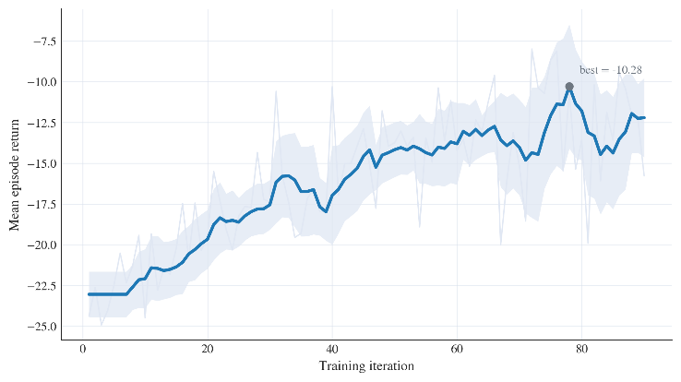
Figure 1. Training reward convergence during PPO optimization.
In a bid to improve reproducibility of the reinforcement learning experiments, the main training parameters are explicitly reported in the manuscript. A practical configuration is to use a learning rate of $3×{10}^{-4}$, a discount factor of 0.99, a clipping coefficient of 0.2, and a mini-batch size of 64. The maximum number of training iterations may be set to $1.0×{10}^{5}$or higher depending on convergence behavior. These settings are not claimed to be universally optimal, but they provide a stable baseline for ecological regulation under the current model structure. After convergence, the learned policy is used in the next section to evaluate resource stability, ecological load suppression, and robustness under varying degradation scenarios.
- Simulation and Results
5.1 Experimental Setup
Simulation experiments were conducted over a horizon of 500 decision steps in a bid to evaluate the long-term regulation performance of the proposed method under random degradation. At the beginning of each episode, the state variables were initialized within admissible operating ranges around the nominal equilibrium point, so that the system started from a feasible but not perfectly balanced ecological condition. During simulation, subsystem reliability decayed progressively according to the degradation model introduced in Section 2, while random disturbances were injected into the transition dynamics to represent uncertainty in recovery efficiency, energy availability, and environmental fluctuation.
The PPO policy was trained using the parameter settings reported in the previous section. For evaluation, each experiment was repeated over 50 independent runs, and all reported results correspond to average performance across these runs. This repeated test design was used to reduce the influence of random initialization and trajectory noise, thereby making the comparison between the learned policy and the threshold-based baseline more reliable. The baseline controller was implemented using fixed safety thresholds and rule-based corrective actions, which provides a natural reference because such logic is widely used in practical ecological regulation.
5.2 Resource Stability
The PPO-based policy maintained all major resource variables within admissible operating ranges throughout the simulation horizon. Compared with the threshold-based controller, the PPO-based policy exhibited smaller fluctaion and smoother recovery behavior after disturbances. This difference is especially evident in the water and oxygen trajectories, where the baseline controller tended to react only after the state approached a safety boundary, whereas the learned policy adjusted regulation intensity earlier and avoided large excursions from the nominal operating point.
The proposed policy reduced water storage variation by approximately 42%, oxygen concentration fluctuations were moderately reduced, and energy variance by 25% relative to the threshold-based strategy. These improvements indicate that the learned policy does not merely keep the system within hard safety limits, but also improves the smoothness of internal regulation. Such behavior is valuable in long-duration operation because repeated large-amplitude oscillations may accelerate subsystem wear and reduce long-term sustainability.
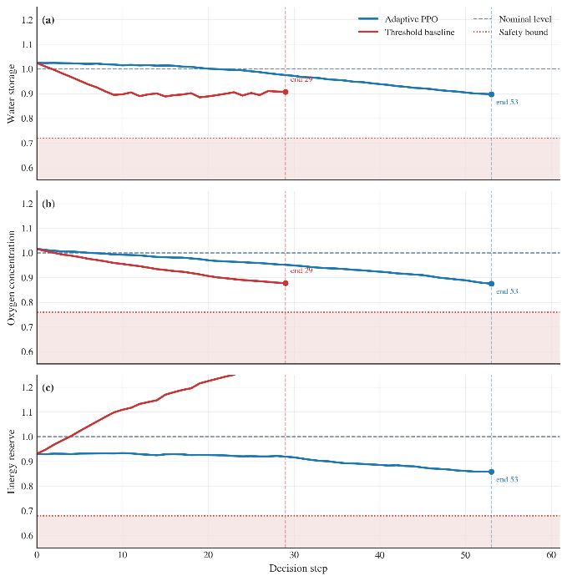
Figure 2. Resource state trajectories under adaptive policy and threshold control.
5.3 Ecological Load Suppression
In addition to improving short-term resource stability, the proposed policy also reduced long-term ecological stress. Because ecological load accumulates as a function of persistent deviation from nominal operating conditions, it provides a more stringent measure of regulation quality than simple threshold satisfaction. A controller may keep all variables feasible while allowing repeated deviations that gradually increase internal pressure. This effect was clearly observed in the baseline strategy.
Under the PPO-based reinforcement learning policy, ecological load accumulation was reduced by approximately 38% compared with the threshold-based controller. This improvement indicates that the PPO policy was able to coordinate resource recovery and energy expenditure more effectively over time, instead of relying on short-term corrective actions. In particular, the learned controller tended to suppress deviation earlier, which limited the cumulative growth of environmental burden across the episode.
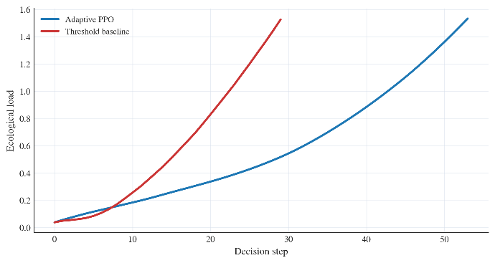
Figure 3. Ecological load evolution under adaptive PPO regulation and threshold-based control.
5.4 Robustness Under Degradation
To evaluate robustness, the degradation coefficient was varied across multiple scenarios while keeping the control structure unchanged. This experiment was designed to test whether the learned policy remained effective when the ecological system worsen faster than the nominal case. The results show that the adaptive policy preserved stable operation over a wider degradation range than the threshold-based baseline. Even when degradation was accelerated, the learned policy continued to allocate regulation effort in a balanced manner and prevented abrupt ecological collapse.
An important result is that the proposed strategy extended safe operational duration by nearly 90% under accelerated degradation. This indicates that the policy learned not only nominal regulation behavior but also a meaningful degree of degradation awareness. Instead of exhausting control effort too early, it adjusted energy allocation and recycling regulation more conservatively, preserving future regulation capacity.
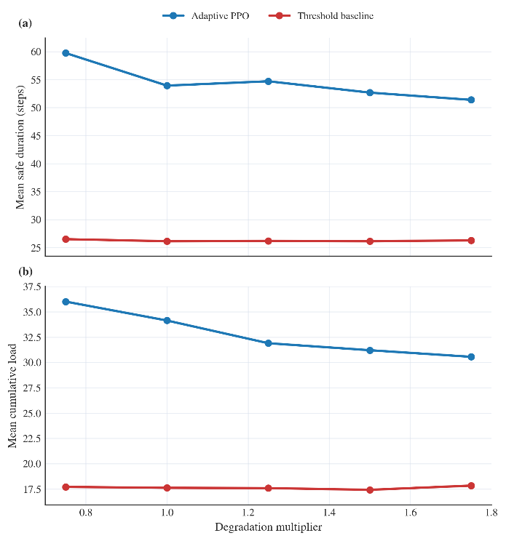
Figure 4. System performance under different subsystem degradation rates.
Consequently, the results show that the PPO-based controller improves both short-term stability and long-term ecological sustainability. It reduces the amplitude of resource fluctuations, suppresses cumulative ecological load, and maintains stronger robustness under progressive subsystem degradation. These findings support the use of reinforcement learning for regulation of micro closed-loop space station life-support systems.
- Discussion
The proposed PPO-based regulation framework does not merely react to ecological imbalance after it appears, but instead learns a predictive control strategy that adjusts regulation effort before major deviations accumulate. This behavior distinguishes the PPO-based controller from conventional threshold-based regulation. In the baseline strategy, corrective actions are typically triggered only when one or more state variables approach predefined safety limits. Such delayed intervention is sufficient for preventing immediate failure in mild scenarios, but it often produces larger oscillations and stronger cumulative ecological stress over long-duration operation. By contrast, the learned policy distributes control effort more gradually. Therefore it achieves smoother trajectories and lower long-term environmental burden.
Another vital implication of the results is that subsystem reliability should not be treated as an external background factor. In the present framework, reliability is explicitly coupled with recycling efficiency and ecological load evolution. This integration allows the controller to account for the fact that the same regulation action may have different consequences under different subsystem conditions. As a result, the learned strategy exhibits a degree of degradation awareness rather than simply optimizing resource balance. This property is particularly important in long-duration space station operations, where subsystem aging is unavoidable and delayed effects can accumulate over many decision cycles.
The proposed framework also has practical extensibility. Although the current model focuses on water, oxygen, energy, reliability, and ecological load, the same decision architecture can be extended to include additional modules such as waste processing, thermal regulation, or carbon dioxide control. In this sense, the present study should be understood as a compact proof-of-concept rather than a fully detailed engineering simulator.
At the same time, several limitations should be acknowledged. The current state-transition model is intentionally simplified in a bid to make policy learning tractable within a compact framework. Some physical processes, ranging from detailed subsystem latency, maintenance scheduling to nonlinear cross-coupling between environmental variables, are not explicitly modeled. In addition, the simulation study is based on synthetic degradation scenarios rather than real telemetry data from operational life-support systems. Future work should therefore focus on incorporating higher-loyalty subsystem models and validating the control framework against engineering data or hardware-in-the-loop experiments.
- Summary/Conclusions
This study developed a reinforcement learning–based adaptive regulation framework for micro closed-loop space station ecosystems using Proximal Policy Optimization. A compact state-space model was constructed to represent the integrated evolution of water storage, oxygen concentration, energy reserve, subsystem reliability, and ecological load. On this basis, ecological regulation was formulated as a sequential continuous-control problem under stochastic disturbances and operational constraints.
Simulation results showed that the learned policy maintained the main resource variables within admissible operating ranges while improving both short-term stability and long-term sustainability relative to threshold-based regulation. In particular, the proposed method reduced water, oxygen, and energy fluctuations, suppressed cumulative ecological load, and preserved stronger robustness under accelerated subsystem degradation. These results indicate that policy optimization can provide a more effective regulation mechanism than purely reactive control logic in coupled ecological systems.
The main contribution of this work is not the introduction of a large-scale habitat model, but the demonstration that reliability-coupled ecological regulation can be addressed within a compact sequential decision framework. This provides a scalable basis for autonomous regulation of life-support subsystems in long-duration space station missions. Further improvements should focus on integrating higher-fidelity subsystem dynamics, richer disturbance models, and engineering validation with realistic operational data.
References
- Schulman, J., Wolski, F., Dhariwal, P., Radford, A., and Klimov, O., “Proximal Policy Optimization Algorithms,” http://arxiv.org/abs/1707.06347, 2017, doi:https://doi.org/10.48550/arXiv.1707.06347.
- John, S., Moritz, P., Levine, S., Jordan, M.I., and Pieter Abbeel, “High-Dimensional Continuous Control Using Generalized Advantage Estimation,” ArXiv (Cornell University), 2015, doi:https://doi.org/10.48550/arxiv.1506.02438.
- Sutton, R.S. and Barto, A., “Reinforcement learning: An introduction,” 2nd ed., The Mit Press, Cambridge, Ma ; London, ISBN 9780262039246, 2018.
- Pouria Razzaghi, Amin Tabrizian, Guo, W., Chen, S., Taye, A., Thompson, E., Bregeon, A., Baheri, A., and Wei, P., “A survey on reinforcement learning in aviation applications,” Engineering Applications of Artificial Intelligence 136:108911–108911, 2024, doi:https://doi.org/10.1016/j.engappai.2024.108911.
- Sharma, G. and Rai, R.N., “Reliability modeling and analysis of environmental control and life support systems of space stations: A literature survey,” Acta Astronautica 155:238–246, 2019, doi:https://doi.org/10.1016/j.actaastro.2018.12.010.
- Fili, T., Gòdia, F., and González-Cinca, R., “Trade-off analysis of phase separation techniques for advanced life support systems in space,” Acta Astronautica 178:571–583, 2021, doi:https://doi.org/10.1016/j.actaastro.2020.09.052.
- Shkedi, B.D., “Lessons Learned from the International Space Station (ISS) Environmental Control and Life Support System (ECLSS) Water Subsystem,” SAE International Journal of Aerospace 1(1):78–83, 2008, doi:https://doi.org/10.4271/2008-01-2008.
- Nimelman, M., “International space station (ISS) robotic work station system,” IFAC Proceedings Volumes 31(33):83–87, 1998, doi:https://doi.org/10.1016/s1474-6670(17)38391-x.
- Raihan, A., “Toward sustainable living in space: A review of environmental control and life support system technologies,” Space Habitation 2(1):100047, 2026, doi:https://doi.org/10.1016/j.spaceh.2025.100047.
Declaration of AI-Assisted Technologies
During the preparation of this manuscript, AI-assisted tools were used only for grammar checking and language refinement. All modeling, algorithm design, simulation development, result interpretation, and scientific conclusions were independently completed and verified by the authors. The authors take full responsibility for the integrity and originality of the content.
Contact Information
Corresponding author: Heyang Zhang
Sichuan University, Chengdu, China
Email: zhangheyang1@stu.scu.edu.cn

________________________________________________________________________________________________________________________
© 20XX SAE International. All rights reserved. No part of this publication may be reproduced, stored in a retrieval system, transmitted, in any form or by any means, electronic, mechanical, photocopying, recording, or otherwise, or used for text and data mining, AI training, or similar technologies, without the prior written permission of SAE. Positions and opinions advanced in this work are those of the author(s) and not necessarily those of SAE International. Responsibility for the content of the work lies solely with the author(s).
Paper presented at Conference Full Name, Chendu, China, June 6-9, 2025.
ISSN 0148-7191

